Software Requirements Specification
for
Recommendation of doctors and medicines using review mining
Prepared by Anita Waghmode
Monica Mandage
Pragati Vhatkar
Sahil Shah

VIIT
Created on-18/09/2018
Table of Contents
Table of Contents ii
Revision History ii
1. Introduction 1
1.1 Purpose 1
1.2 Document Conventions 1
1.3 Intended Audience and Reading Suggestions 1
1.4 Product Scope 1
1.5 References 1
2. Overall Description 2
2.1 Product Perspective 2
2.2 Product Functions 2
2.3 User Classes and Characteristics 2
2.4 Operating Environment 2
2.5 Design and Implementation Constraints 2
2.6 User Documentation 2
2.7 Assumptions and Dependencies 3
3. External Interface Requirements 3
3.1 User Interfaces 3
3.2 Hardware Interfaces 3
3.3 Software Interfaces 3
3.4 Communications Interfaces 3
4. System Features 4
4.1 System Feature 1 4
4.2 System Feature 2 (and so on) 4
5. Other Nonfunctional Requirements 4
5.1 Performance Requirements 4
5.2 Safety Requirements 5
5.3 Security Requirements 5
5.4 Software Quality Attributes 5
5.5 Business Rules 5
6. Other Requirements 5
Appendix A: Glossary 5
Appendix B: Analysis Models 5
Appendix C: To Be Determined List 6

Revision History
Name | Date | Reason For Changes | Version

Introduction

Purpose
Medical data are an ever growing source of information generated from hospitals consisting of patient records in the form of hard copies which can be made easier and convenient by using QR code of the patient details. Our aim is to build a Health-care Portal system which will provide the features like clinical management, patient records, disease prediction and generate QR code for every patient as per there updated disease information.

Document Conventions
This document uses the following conventions.

DB | Database
ER | Entity Relationship

Intended Audience and Reading Suggestions
Our aim is to build a Health-care Portal system which will provide the features like clinical management, patient records, disease prediction and generate QR code for every patient as per there updated disease information. Key logging or keyboard capturing is the activity of recording (or logging) the keys struck on a keyboard, normally in a secretive way so that the individual utilizing the keyboard is unconscious that their activities are being observed. It likewise has exceptionally authentic uses in investigations of human-computer interaction.

Product Scope
We will study methods for improving the security and user experience by means of visualization in other contexts, but not limited to authentication such as visual decryption and visual signature verification. Finally, reporting on user studies that will benefit from a wide deployment and acceptance of our protocols would be a parallel future work to consider as well. We analyzed the use of user- driven visualization to improve security and user-friendliness of authentication protocols. Moreover, we have shown two realizations of protocols that not only improve the user experience but also resist challenging attacks, such as the keylogger and malware attacks. Our protocols utilize simple technologies available in most out-of-the- box smartphone devices. We developed Android application of a prototype of our protocol and demonstrate its feasibility and potential in real-world deployment and operational settings for user authentication.

References
- R.Pemmaraju Methods and apparatus for securing keystrokes from being intercepted between the keyboard and a browser. Patent 182,714.
- N. Hopper and M. Blum. Secure human identification protocols. In Proc. of ASIACRYPT, 2018
- DaeHunNyang, Member, IEEE, Aziz Mohaisen, Member, IEEE, Jeonil Kang, Member, IEEE, “Keylogging-resistant Visual Authentication Protocols” -IEEE TRANSACTIONS ON MOBILE COMPUTING, VOL. 13, NO. 11, NOVEMBER 2017
- J. Bonneau, C. Herley, P.C. Van Oorschot, and F. Stajano, “The Quest to Replace Passwords: A Framework for Comparative Evaluation of Web Authentication Schemes,” Proc. IEEE Symp. Security and Privacy (SP), pp. 553-567, 2018.
- M. Farb, M. Burman, G. Chandok, and J. McCune, “A. Perrig, “SafeSlinger: An Easy-to-Use and Secure Approach for Human Trust Establishment,” Technical Report CMU- CyLab-11-021, Carnegie Mellon Univ., 2018.

Overall Description

Product Perspective
1. Patient:
- Registration
- Login
- Logout
A. Registration
- The patient will register to the system with normal information.
- At the time of registration patient will enter valid Email-ID and receives QR code on his Email-ID which in encrypted format.
B. Login
- For login to the system, patient will enter the Email and password, if entered details are correct then the system will redirect him to home page otherwise it will shows an error message.
After Login:
- Patient will enter the symptoms.
- Then patient get disease result and generate QR code and sent to patients Mail ID.
- Patient will search for doctor as per disease shown by system.
- Patient will get result of doctors.
C. Logout

- Patient logout the account from system.

2. Doctor
- Registration
- Login Scanner
- Logout
A. Registration

- Doctor will register to the system with normal information.
B. Login into Scanner.
- Patient gives QR code to the doctor which is received in his mail ID.
- Doctor login into scanner.
After Login:
- Doctor scans and decrypts the QR code.
- Then gives prescription and medicine in QR code format and send to patient Mail ID.
- The alert will be generated and send to user on his profile regarding prescription.
C. Logout

- Doctor Logout the account from system.

Product Functions
The major features of system as shown in below entity–relationship model (ER model)

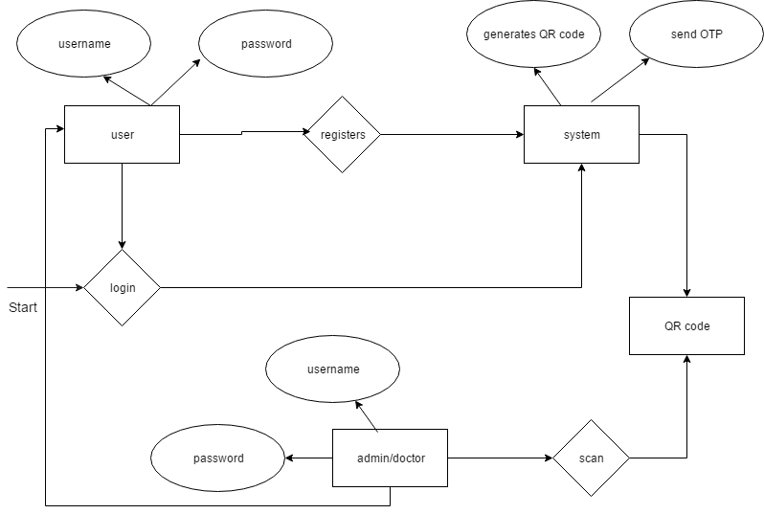

User Classes and Characteristics
- The patient info apps ( this is accessible to doctor only)
- Contains patients list
- patient summary
- lab results
- medication list,
- clinical notes
- vital signs
- allergies
- current treatment information
- Doctor notes.

3. Pharmacist
- Login Scanner
- Logout
A. Login into Scanner.
- Patient gives prescription QR Code which is received in his mail ID.
- Pharmacist login into scanner.

After Login:
- Pharmacist scans and decrypts the QR code.
- Then give medicine to patient.
B. Logout

- Pharmacist Logout the account from system.

Operating Environment
Operating environment for this system is as listed below.

- Operating system : Windows XP/7.
- Coding Language : JAVA/J2EE, Hibernate.
- IDE : Java eclipse.
- Web server : Apache Tomcat 7.
- Front End : JSP, CSS etc/Android.
- Back End : MySQL as database server.

Design and Implementation Constraints
- The global schema, fragmentation schema, and allocation schema.
- SQL commands for above queries/applications
- How the response for application 1 and 2 will be generated. Assuming these are global queries. Explain how various fragments will be combined to do so.
- Implement the database at least using a centralized database management system.

User Documentation

User Manual

User need to register firstly at the time of registration user will add all related details
- After that user needs to fill symptoms form

- And user will get the predicted disease

- The Qr code will generate of all these information

- Patient need to visit doctor and doctor will scan qr code and it he will prescribe medicines

- Medicinal information’s qr code will be generated and he will bring that qr code to the medical

- Medical will scan and provides medicines

Assumptions and Dependencies
Let us assume that this is a distributed Secure Exam system and it is used in the following application:
1) This system is used in any organizations (hospital, bank) for security and authentication
2) It reduce paper work

External Interface Requirements

User Interfaces
- Front-end software: Java/Android
- Back-end software: MYSQL

Hardware Interfaces
- Windows.
- A browser which supports HTML & Java script.

Software Interfaces
Software used | Description
Operating system | We have choosen Windows operating system for its best support and user-friendliness.
Database | We have choosen MySQL+ database.
Java | To implement the project we have choosen Java language for its more interactive support.

Communications Interfaces
This project supports all types of web browsers.

System Features

System Feature 1
4.1.1 Description and Priority
Our aim is to build a Health-care Portal system which will provide the features like clinical management, patient records, disease prediction and generate QR code for every patient as per there updated disease information. Key logging or keyboard capturing is the activity of recording (or logging) the keys struck on a keyboard, normally in a secretive way so that the individual utilizing the keyboard is unconscious that their activities are being observed. It likewise has exceptionally authentic uses in investigations of human-computer interaction
4.1.2 Stimulus/Response Sequences
. Results are as per entered users query
    - Functional Requirements
Other system features include:
CLIENT/SERVER SYSTEM
The term client/server refers primarily to an architecture or logical division of responsibilities, the client is the application (also known as the front-end), and the server is the DBMS (also known as the back-end).
A client/server system is a distributed system in which,
- Some sites are client sites and others are server sites.
- All the data resides at the server sites.
- All applications execute at the client sites.

System Feature 2

- It removes the confusion that which doctor should I need to prefer
- Prediction of disease needed for common peoples cause they always ignores normal symtoms and that will converted into serious disease
- Drug addict peoples can’t make fake prescription and buy medicines for drug consumption.

Other Nonfunctional Requirements

Performance Requirements
- The performance of the functions and every module must be well.
- The overall performance of the software will enable the users to work efficiently.
- Performance of encryption of data should be fast.
- Performance of the providing virtual environment should be fast.

Safety Requirements
The application is designed in modules where errors can be detected and fixed easily. This makes it easier to install and update new functionality if required.

Security Requirements
All data will be encrypted using strong encryption algorithm and according to location encryption is done.

Software Quality Attributes
Our software has many quality attribute that are given below:-
- Adaptability: This software is adaptable by all users.
- Availability: This software is freely available to all users. The availability of the software is easy for everyone.
- Maintainability: After the deployment of the project if any error occurs then it can be easily maintained by the software developer.
- Reliability: The performance of the software is better which will increase the reliability of the Software.
- User Friendliness: Since, the software is a GUI application; the output generated is much user friendly in its behavior.
- Integrity: Integrity refers to the extent to which access to software or data by unauthorized persons can be controlled.
- Security: Users are authenticated using many security phases so reliable security is provided.
- Testability: The software will be tested considering all the aspects.

Other Requirements
Appendix A: Glossary
Appendix B: Analysis Models
